1. Creating and Renaming Files/Directories

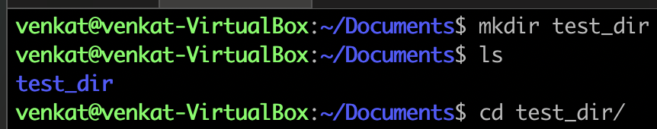I have created a directory named test_dir using “mkdir”.

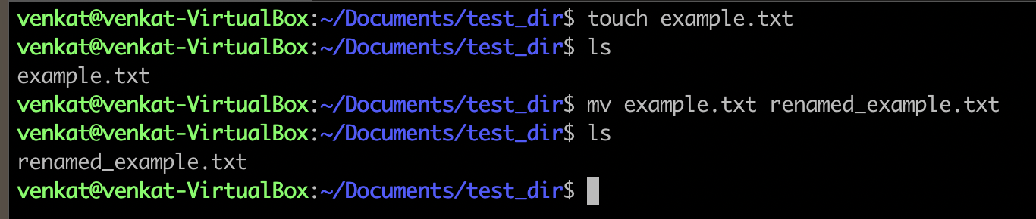

Inside the test_dir, I created an empty file called example.txt.

I am able to rename the file name example.txt to renamed_example.txt using the “mv” command.

2. Viewing File Contents

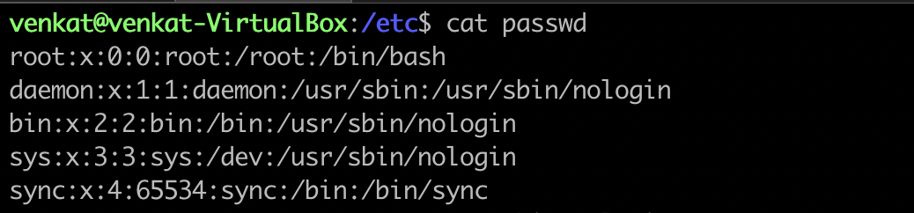

Using the “cat” command here, I displayed the contents inside the /etc/passwd file.

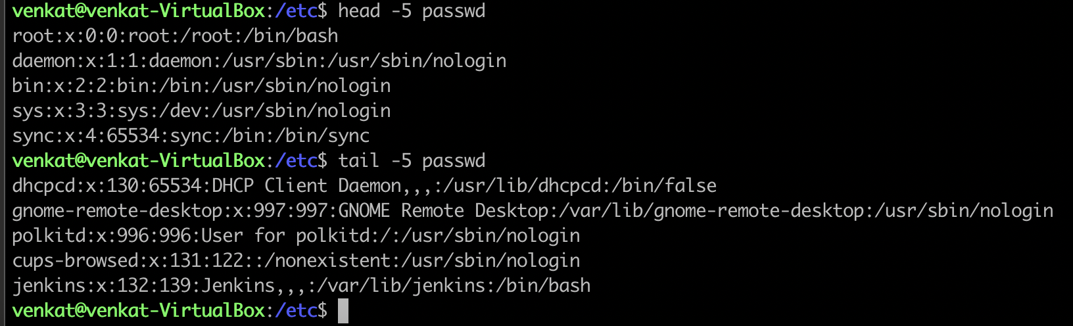

Displayed only the first 5 lines of /etc/passwd using the “head” command.

Displayed only the last 5 lines of /etc/passwd using the “tail” command.

3. Searching for Patterns

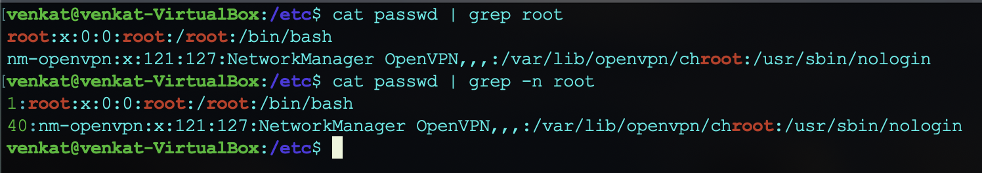

I used the “grep” command to find all lines containing the word "root" in /etc/passwd file.

4. Zipping and Unzipping

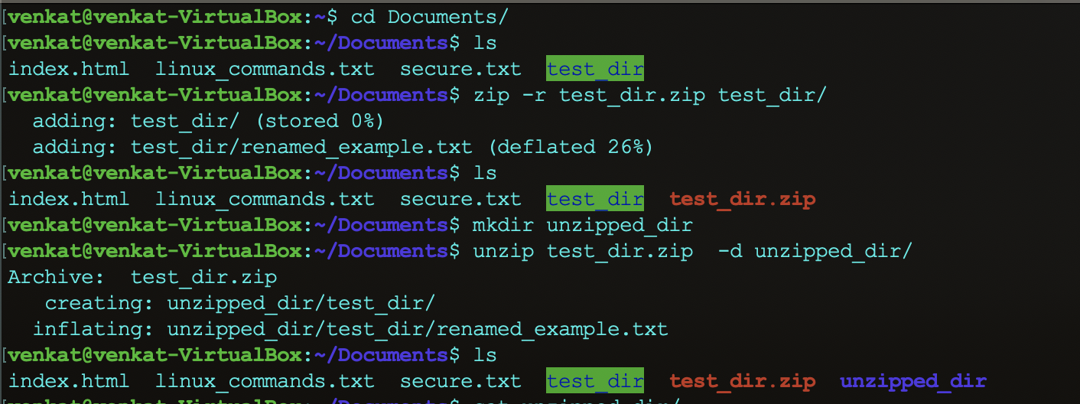

Compressed the test_dir directory into a file named test_dir.zip using “zip”.

I have created a new directory named “unzipped_dir”.

I use the command “Unzip” to unzip the file name test_dir.zip into a new directory named unzipped_dir.

5. Downloading Files

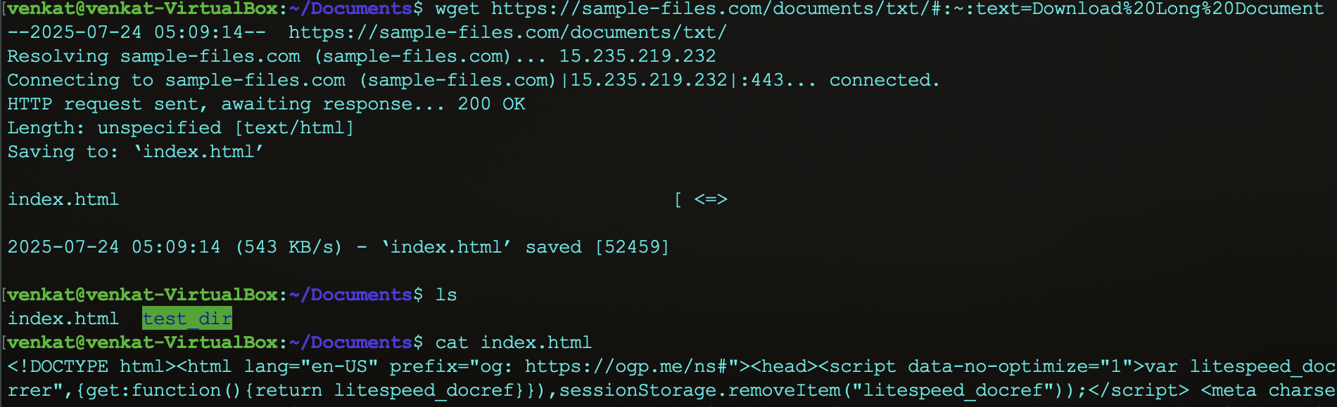

I use the “wget” command to download the file from the following URL (<https://sample-files.com/documents/txt/#:~:text=Download%20Long%20Document>).

6. Changing Permissions

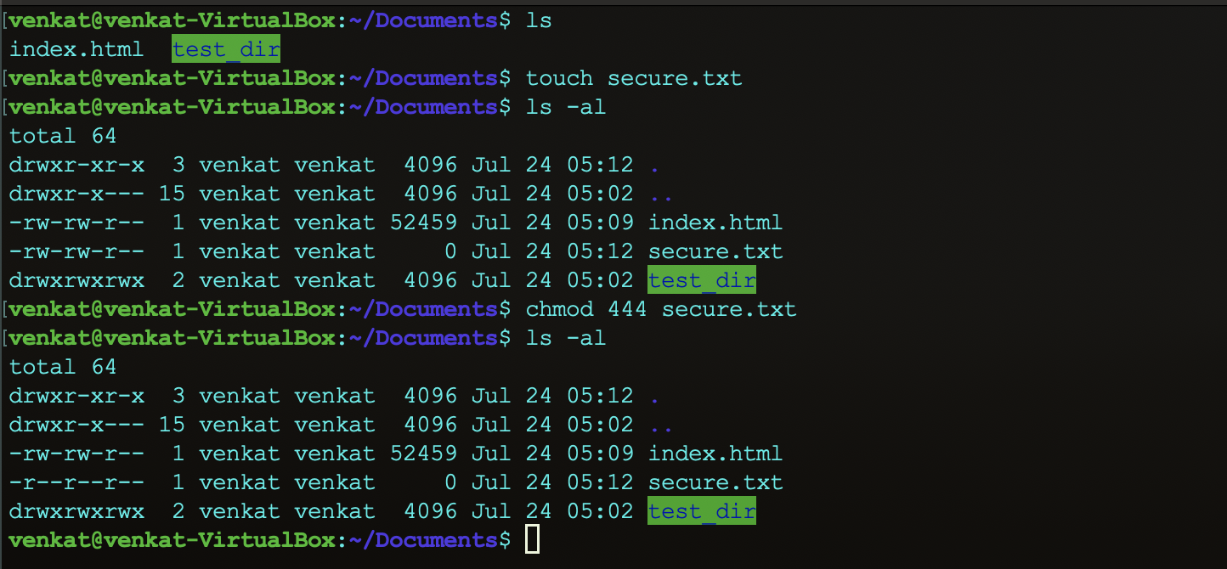

I have created a file named secure.txt and changed its permissions to read-only for everyone using “chmod”.

7. Working with Environment Variables

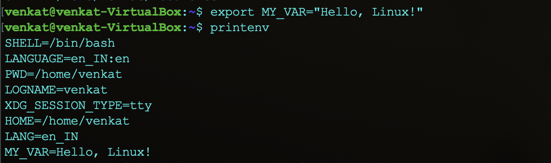

I use the “export” command to set a new environment variable called MY_VAR with the value "Hello, Linux!".

Submission Guidelines -: Attach Screenshots or command along with explanation and submit in doc(google doc or microsoft doc) format also attach github repo link